Disasters happen, and they are unpredictable. With a well-rounded DR strategy, your organization can weather any storm–without a plan, a single disaster can sink your company.

[Cloud technology](https://phoenixnap.com/blog/what-is-cloud-computing) has democratized [disaster recovery](https://phoenixnap.com/blog/what-is-disaster-recovery), making it accessible and affordable for businesses of all sizes. Cloud disaster recovery is a cost-effective, [scalable](https://phoenixnap.com/glossary/scalability), and efficient solution that quickly restores IT infrastructure after a disruption.

This article outlines **the basic and advanced concepts of cloud disaster recovery**. Jump in to see whether cloud-based DR is a good fit for your organization.

**What Is Cloud Disaster Recovery (Cloud DR)?**

Cloud disaster recovery is a set of strategies and services that leverage cloud computing to protect data, [applications](https://phoenixnap.com/glossary/what-is-an-application), and other IT resources from disasters and [hardware](https://phoenixnap.com/glossary/what-is-hardware) failures.

Disasters can be natural, such as floods, hurricanes, and earthquakes, or man-made, such as [cyber-attacks](https://phoenixnap.com/blog/types-of-cyber-attacks) and power outages.

**Why Is Cloud Disaster Recovery Important?**

Cloud disaster recovery quickly restores IT systems' functions, minimizing [downtime](https://phoenixnap.com/glossary/downtime) and disruption to business operations.

Maintaining operational resilience is vital, as [60%](https://www.inc.com/joe-galvin/60-percent-of-small-businesses-fold-within-6-months-of-a-cyber-attack-heres-how-to-protect-yourself.html) of small businesses close within six months of experiencing a cyber-attack, and [25%](https://www.fema.gov/press-release/20230502/stay-business-after-disaster-planning-ahead) never reopen after a disaster.

Despite these statistics, only [54%](http://web.archive.org/web/20210802180907/https:/www.iland.com/press-release/frequent-disaster-recovery-testing-critical/) of organizations have an established [disaster recovery plan](https://phoenixnap.com/blog/disaster-recovery-plan-checklist). Although 57% of surveyed companies have a second [on-prem](https://phoenixnap.com/glossary/on-premise) data center dedicated to disaster recovery, this approach can be expensive and complex.

Cloud disaster recovery offers a more cost-effective alternative for businesses of all sizes.

Check out our article on the most recent and relevant [disaster recovery statistics](https://phoenixnap.com/blog/disaster-recovery-statistics).

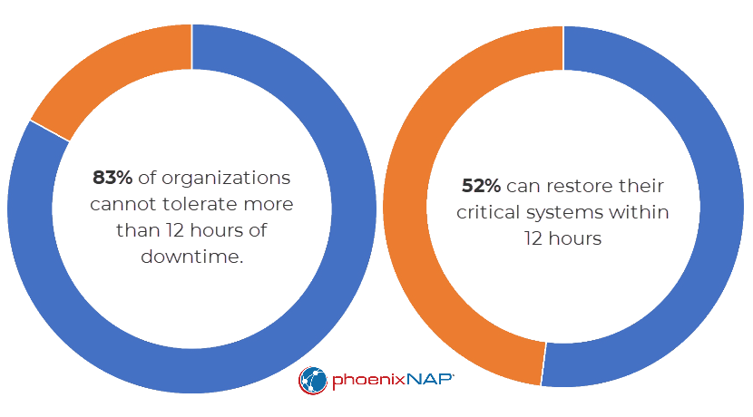

**How Does Cloud-Based Disaster Recovery Work?**

Cloud disaster recovery works by replicating data and apps in a cloud-based environment using three primary strategies.

**Cold Disaster Recovery (Cold DR)**

Cold DR is the most straightforward and cost-effective disaster recovery approach but has the longest recovery time.

Cold DR involves storing data or [virtual machine (VM)](https://phoenixnap.com/glossary/what-is-a-virtual-machine) images in the cloud. However, they are not readily usable and require additional restoring steps, such as downloading up-to-date data or loading VM images.

**Warm Disaster Recovery (Warm DR)**

Warm DR is a standby system that maintains up-to-date duplicates of data and apps in the cloud. These duplicate resources are not actively processing data, but you can quickly activate them in a disaster. Warm DR recovery is relatively fast, but there is still some downtime for the protected workloads.

**Hot Disaster Recovery (Hot DR)**

Hot DR is the most expensive and intricate disaster recovery approach, offering the fastest recovery time with zero downtime. Hot DR operates with a live parallel deployment, where data and workloads run concurrently in both the primary [data center](https://phoenixnap.com/glossary/what-is-a-data-center) and the DR site.

Both sites share the same workload, staying synchronized and splitting the app traffic. If disaster strikes one site, the other seamlessly continues operations without interruption.

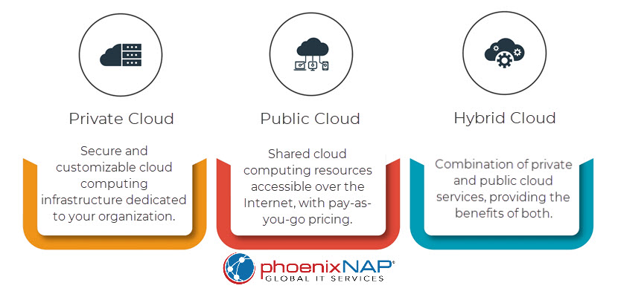

**Cloud DR vs. Traditional DR**

Cloud computing is mature and reliable, offering virtually identical performance to traditional DR solutions. However, there are still scenarios where traditional disaster recovery is superior.

|  |  |  |
| --- | --- | --- |
| **Point of comparison** | **Cloud disaster recovery** | **Traditional disaster recovery** |
| **Cost** | Cost-effective for small and medium-sized businesses | More expensive upfront but eventually cost-effective for large businesses with complex requirements |
| **Flexibility** | Highly flexible, can be deployed quickly and easily | Less flexible, complex, and time-consuming to deploy |
| **Scalability** | Can be scaled up or down without purchasing additional hardware or software | Requires purchasing additional hardware and software to scale |
| **Geo-redundancy** | Enables easy data replication to multiple cloud regions | Difficult to achieve geo-redundancy |
| **Connectivity** | Requires a reliable internet connection | May not require an internet connection |

If you have invested in traditional DR resources, such as a secondary data center and [backup and recovery (BDR)](https://phoenixnap.com/blog/backup-and-disaster-recovery) software, you should continue using them until they are fully depreciated. In this scenario, switching to cloud DR is costly and unnecessary.

**Cloud DR vs. DRaaS**

Cloud disaster recovery requires a do-it-yourself approach to DR. You select a cloud platform to host data and apps and your team is responsible for managing the replication and failover process.

**Note:** Learn about the [differences between a failover and failback](https://phoenixnap.com/kb/failover-vs-failback).

On the other hand, disaster recovery as a service (DRaaS) is a managed service. A DRaaS provider designs and implements a disaster recovery solution for you, and they manage the replication and failover process on your behalf.

|  |  |  |
| --- | --- | --- |
|  | **Cloud disaster recovery** | **Disaster recovery as a service** |
| **Flexibility** | High | Lower |
| **Cost** | Varies depending on your implementation | Typically more expensive than cloud DR |
| **Complexity** | High | Lower |
| **Expertise required** | Significant | Low |
| **Management responsibility** | In-house team | DRaaS provider |

**Challenges of Cloud DR**

Cloud disaster recovery offers many advantages, but it has its drawbacks. Here are the most common challenges:

* **Migration costs**. [Cloud migration](https://phoenixnap.com/blog/what-is-cloud-migration) is expensive, especially for large and complicated environments.
* **Complex implementation**. Compared to DRaaS, cloud DR is complex to implement and manage.
* **Consistent connectivity.** Cloud DR requires steady connectivity and reliable internet access.
* **Vendor lock-in.** Once you have implemented a cloud solution, switching to a different provider can be difficult. This issue is known as [vendor lock-in](https://phoenixnap.com/glossary/vendor-lock-in).
* **Dependence on third-party providers**. Cloud DR makes you dependent on the [uptime](https://phoenixnap.com/glossary/what-is-uptime) and security of third-party providers.

**Business Continuity & Disaster Recovery in the Cloud**

Business continuity is an organization's ability to continue operating during a disruption. Cloud disaster recovery bolsters business continuity by protecting data and minimizing downtime.

For example, an organization can replicate its data and apps to the cloud, quickly recover from a disaster at its primary facility, and resume business. There's zero downtime or service disruption.

**Note:** Learn more about what it takes to successful